PROJECT ON DESIGNING A TOBOGGAN
Student Name
Institution
Course Name/Number
Due Date

Introduction
The game of sloping down a snow-covered slope with fake ice curtains wrapped in a non-slip slide called slide. In Europe, small sleds with sprinters are also called toboggans (Znojil, 2008). Translation of the cut edge is usually done with green, straight sheets of hickory, birch, or oak stitched together with light crosspieces. Some are made of stainless steel or wood (Lin et al., 2006). The front of the front is bent and backwards to enclose the hood and is driven by a rope or straps of calf leather. The sliding surface is about 18 inches (45 cm) wide and 4 to 9 feet (1.2 to 2.7 m) long. The sled is lightweight and will carry a heavy load on sensitive ice. It is well-equipped to slide open slides, where its large area successfully climbs on the free, covered ice. Few people can ride at the same time, either while lying down or sitting down. The sled can be straightened by lifting and folding the front or by dragging a foot into the snow. It is equally helpful to pull loads over the wild or cross-country route as a sport (Lin et al., 2006).
Sledding as a sport may have begun in the Mount Illustrious valleys in Montreal. During the latter part of the 1880s it spread to the US, where it had its impressive abundance until the mid-1930s, when the unbridled excitement of skiing gained its famous decay. During the early sledding, many deceptive chutes were formed (Robinson, 2010). They were about ten feet [3 m] wide at the sides of the ice or wood and most of the time worked with several equal tracks to force over each sled in a row. The chute was too high to speed up the sled. Scores of up to 96.6 miles per hour were obtained. From the lower part of the cocoon, the retrospective sleds will dry at a moderate, open track (Robinson, 2010). Many chutes are still in use. The rivalry of world sledding rivals is often portrayed as tobogganing, yet it actually involves wrapping, rubbing, and bending the bones as well.
Trail sleds are basically a hand-drawn variable for winter explorers. Long and moderate, the sleds are designed to keep the pile low on the ground with the greatest reliability. A large running area allows you to slide along the coast on your snowy track and go anywhere you do - don’t adapt to snow conditions. Able to adapt, the sled is actively following the formation of landslides, and lifting fallen trees quickly (Davies, 2015). The sleds are completely cut off from the general state of the ‘last resort’ to improve conversion performance.
Materials needed
- Kit content
Sled units from Draw of the North come in standard and premium at 8 ', 10' and 12 'in length (Piskoty et al., 2007). With the exception of the various plastic components used in the running space, all other items are inseparable from the premium units and standard standards.
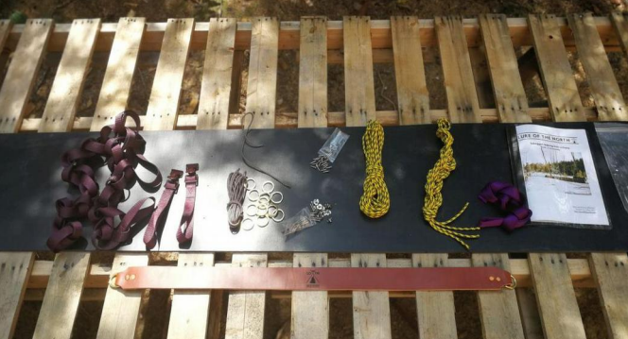
Fig 1: Kit content (Piskoty et al., 2007).
The table below what the kit for toboggan contains (Piskoty et al., 2007).
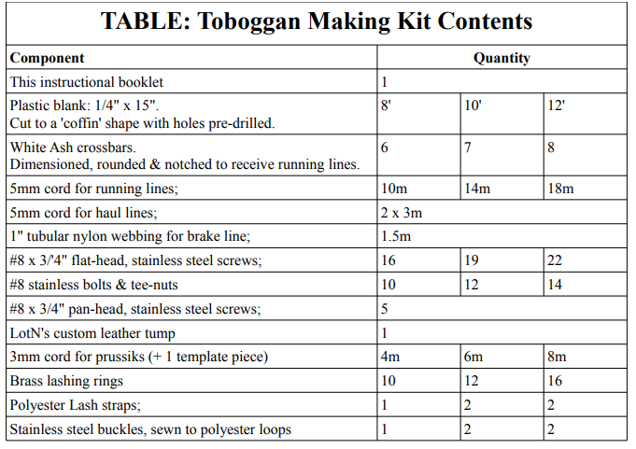
NB: Lengths of lines, pull lines, brake lines, and so forth are continually being refined and changed, and may not by and large match the lengths recorded previously.
- Tools needed
• Driving / driver with related pieces:
◦ 7/64 ", 11/64", 15/64 ", 1/4";
◦ 1/2 "small set;
Bit # 2 Robertson slow drive;
Bit # 2 Phillips drive slow;
• Hand screw driver;
• Electrical tape to seal mass decay into bits;
• Lint oil, marine stain or your exterior wood finish # 1
• Measuring tape and marking;
• 2 x small cinches;
• Writing (can be drawn by hand, given guidelines);
• Smooth pointed hammer;
• Heat gun, hair dryer or other source of heat;
• A simple heat extinguisher is closed;

Procedure
You have found 6 to 8 sections of the path filled with White Debris bales, including one "headboard".
This should be done later:
1. Clean and trim some pieces of metal that cut off the sides so that you can clean any stray strands or saw marks that may bother you;
2. Apply the outer finish to the crossroads and allow to dry. I like two layers of refined oil,
despite the fact that maritime warfare can make the right decision.
This is a data step, intended to help you familiarize yourself with the sled format.
• Your plastic sheet has been pre-cut into a 'final resting place'. That is, it is reinforced in
eliminates both. There is a short, sharp position on the front or 'top' of the sled, in addition, an extended, sloping position at the end or 'tail' of the sled.
• You will notice that there are openings in the front of your plastic sheet. This shows the locations of the crossbars. The openings may not have been previously introduced to the first and last crosses, as their locations are visible.
• All shortcuts will have 5 incomplete grips (usually a combination of screws and bolts), however only three internal holes have been installed previously. This is because the location of the two external screws must be precise and will only be communicated to you after the crossing instruments have been introduced.
1. Whenever you are wanted, you can take a sharp blade, and, collect any unpleasant edges on your sled piece.
2. If you happen to follow a bunch of three open spaces until you get to the edge of your plastic, you should see, just a little bit, a piece of black plastic marker (Sure, it's dark in the dark, but look for something
unclear location). This writing helps you focus on your main bar in addition to the openings included. If you do not see this text, then you can use one of your extended crossbars as a straight edge to stamp yourself. Just turn the crossbar and the pile of 3 openings, and make a mark on the plastic. Make marks like these on both sides of the plastic with each set of open spaces.
3. In the event that there are any harsh imprints on your remaining plastic, place that spot down at this point. You will need the smooth side to the top during development as it will turn into a slippery surface. With the exception of the main board, all road crossings will be intersected from bottom to top - using plastic first.
• This progression ends quickly with 3 tests: 1 in turn on aircraft opener, 1 on set set and 1 on screws.
1. Place the plastic in 2 x 4, or use another aim to lift the edges of the sling to make it easier to make simple cinching;
2. Spot crossbar # 2 under the plastic and attached to the first opening of your ceiling (~ 12 "back from the front edges). and the fixed edges are far from the sled.
3. Most shortcuts are suspended just by the width of the sling. Place the CB in order to focus on the plastic sheet. Yes. the plastic should cover the CB in the same way on the other side.
4. Apply Brace CB;
5. Using the pre-provided opening in the plastic, pierce the 7/64 "plane opener on a wooden crossbar. It helps to seal the right amount of your boring items with a marker or a piece of tape.
6. Drill subset opening as shown in the picture. Note: While the pilot / set pilot pieces appear to be abnormal, we have found them to be plastic and do not work as well as the independent structures shown here.
7. Using a drill speed or a slow-set driver, drive three clean screws.
8. Rehash by sitting on normal horizontal roads. Important: See note below for unusual references
on the straight line of the cross.
9. At the last crossing line:
I. Spot the crossbar last around 1/4 "forward behind plastic. This will do less
(1/4 ") The plastic 'lip' that works behind the CB. This cup, although not essential at all, can be helpful in finding a 'push stick' when the next person helps pull the sled back.
ii. There may be 2 arrows at the last cross, next to 4 bolts. The opening can be pre-determined with 2 screws. Provided that this is true, it presents the same as any remaining screws. In the event that the opening is not pre-inserted into the plastic, you should determine their location yourself. This opening is placed in 1/4 and 3/4 the width of the remaining plastic. For example, if your sling is 12 ′ ′ wide at the end of the ball, then you will unravel it at 3 ′ ′ and 9 ′ ′.
10. You can remove the 2x4 you just raised the sled from.

Diagrams for the project
- Top view (Hand drawn)
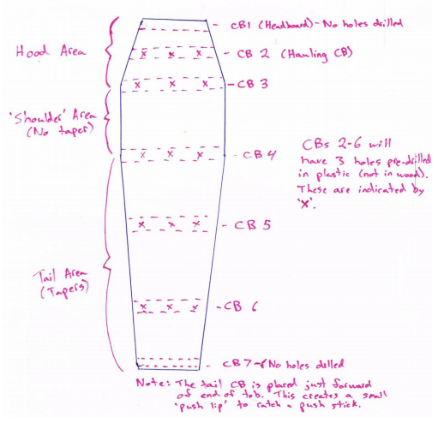

- Toboggan lash system (hand drawn)
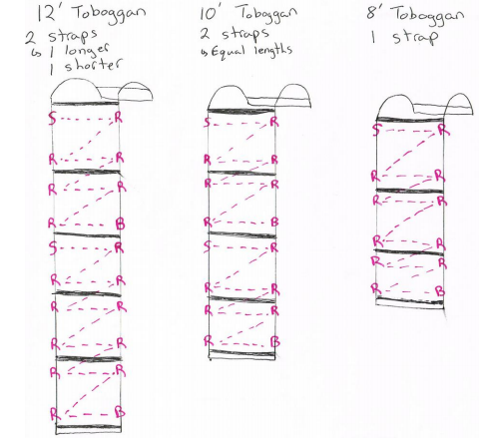

AutoCAD drawings
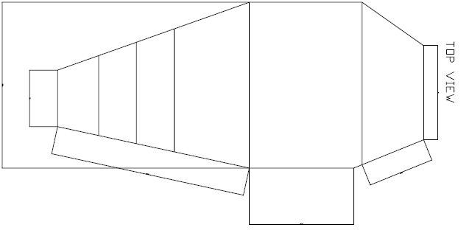

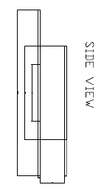
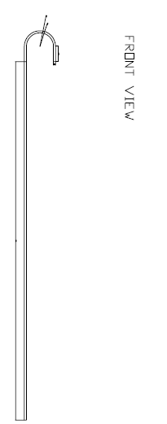
The AutoCAD drawings have been attached.

References
DAVIES, W. K. 2015. Winter cities. Theme cities: Solutions for urban problems. Springer.
LIN, Y.-C., TSAI, Y.-P., HUNG, Y.-P. & SHIH, Z.-C. 2006. Comparison between immersion-based and toboggan-based watershed image segmentation. IEEE Transactions on image processing, 15, 632-640.
PISKOTY, G., KLOTZ, U., KOVACS, G., WEISSE, B., RÜTTI, T. & STUTZ, A. 2007. Analysis of a tragic accident on a summer toboggan run. Engineering failure analysis, 14, 1083-1092.
ROBINSON, L. 2010. Advanced materials are a game changer in the winter olympics. JOM, 62, 17.
ZNOJIL, M. 2008. Two-step identification of observables in PT− symmetric quantum-toboggan models. arXiv preprint arXiv:0803.0403.

